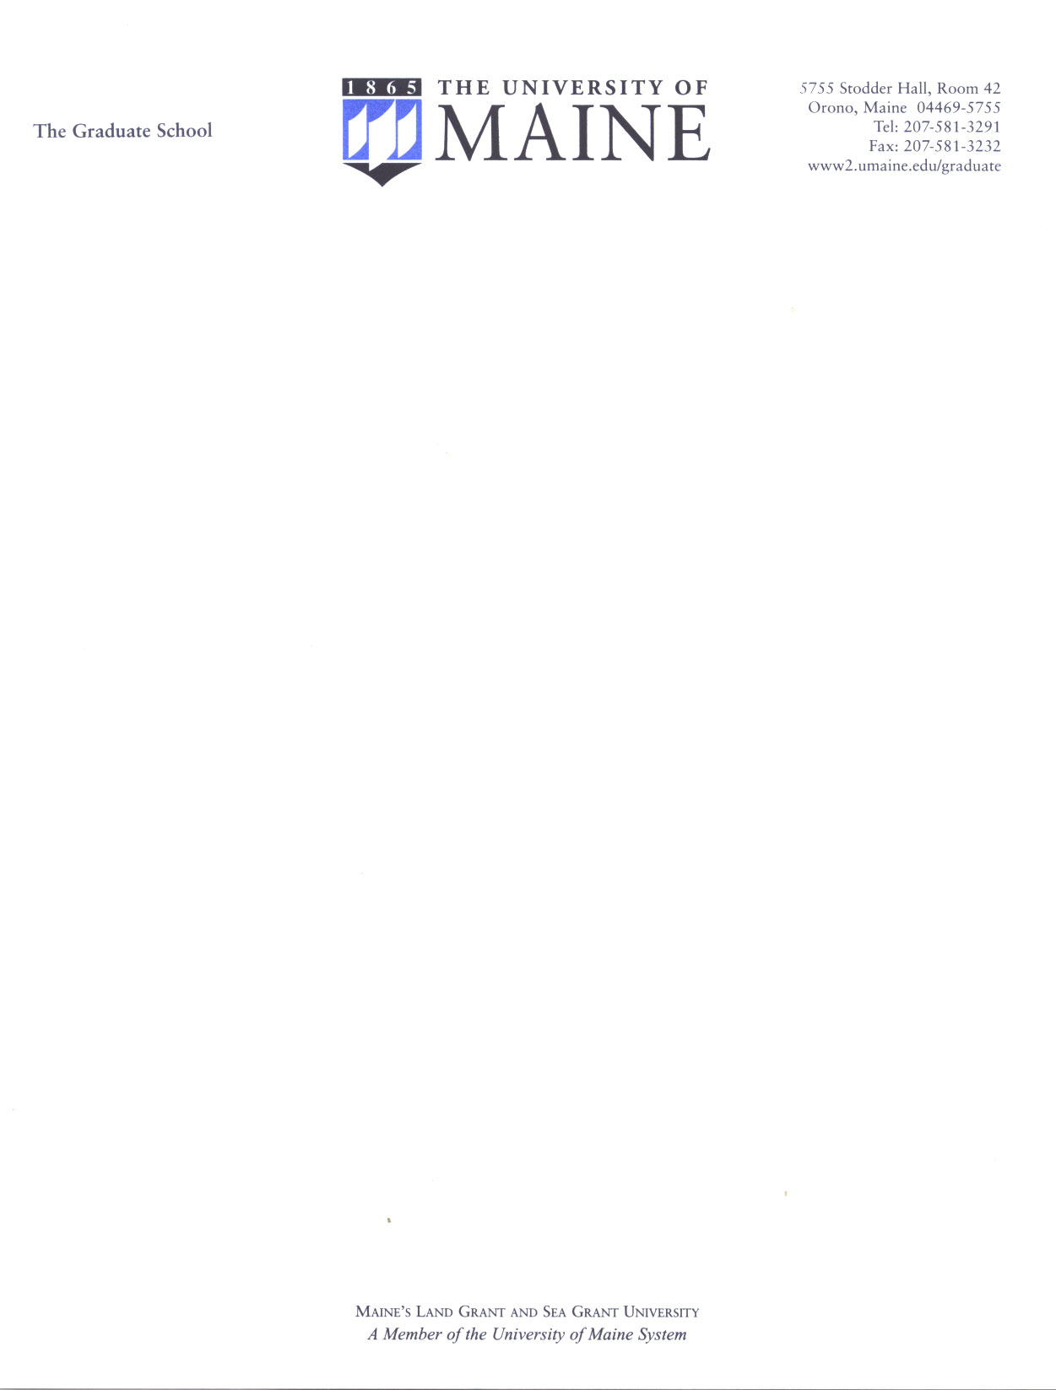

AY 2010 Dissertation & Thesis Studio Application

Name _______________________________________________________________

Currently pursuing (Master’s Doctoral) degree in ___________________________

Working title of your dissertation or thesis:

Please answer the next three questions as thoroughly as you can:

- How would you characterize your work with this project thus far?

- How far along do you feel you are in this project?

- 3. What do you feel you most need to complete your project?

Can you commit to full participation in a minimum of four 2½ hour meetings on campus over the fall semester?

YES ______ NO_________ NOT SURE______

If yes, what best fits your availability for the fall semester?

Mon/Wed: ___ late morning ___ early afternoon ___ late afternoon ___early evening

Tues/Thurs: ___ late morning ___ early afternoon ___ late afternoon ___early evening

